Operation Sentinel
Sohail Platform Defensive Assessment
Blue Team Sprint 1

Prepared for | Sohail Smart Solutions
Author | Saif Alblooshi
Target | OWASP Juice Shop local Docker lab
Date | 24 June 2026
Version | v1.0

Scope statement: All testing was performed against the local OWASP Juice Shop lab at http://localhost:3000. The report is written as a defensive readiness package for Sohail's future EdTech platform and does not authorize testing of public systems.

1. Introduction
This document combines the Detection Engineering section and the Blue Lead Incident Response section for Operation Sentinel. The purpose is to show how attack traffic from a controlled lab can be converted into detection logic, incident response actions, and defensive readiness recommendations for Sohail Smart Solutions. The work is separated into the original team scopes: Safa's Detection Engineering section and Saif's Blue Lead section. Since both sections are included in this package, the document reads as one coordinated defensive assessment.
The lab evidence was collected from OWASP Juice Shop running locally through Docker. Evidence sources include browser Developer Tools screenshots, an exported HAR file, and Docker container logs. The Docker logs show server startup, route errors, unauthorized access messages, challenge completions, and file validation errors. The HAR file provides request-level evidence such as endpoints, methods, status codes, and login request bodies.
The main attack classes covered are reconnaissance and route probing, directory listing and restricted file access, authentication abuse, SQL injection login bypass, XSS payload execution, and a broken access control/IDOR visibility gap.

2. Lab Setup and Evidence Sources
Item | Details
Target | OWASP Juice Shop local lab
Local URL | http://localhost:3000
Container Evidence | docker-logs.txt
Browser Evidence | localhost.har and screenshots
Testing Scope | Controlled local lab only
The submitted Docker logs show unexpected route errors for /api and /rest, an UnauthorizedError for a missing Authorization header, and file validation errors for restricted file types. The HAR evidence shows repeated failed login attempts, a SQL injection-style login request that returned HTTP 200, and requests to the FTP directory and protected-looking routes.

Part A — Detection Engineering Section

3. Detection Engineering Methodology
Detection engineering focuses on identifying what an attack looks like in logs, requests, alerts, or application events. In this lab, the detection logic was based on three data sources: browser request evidence, Docker application logs, and screenshots. Each attack was mapped to a likely MITRE ATT&CK technique so that the detection and response work can connect to real security terminology.
The most complete detections are the ones that produce obvious request patterns, such as SQL injection strings, repeated HTTP 401 login failures, and route-probing attempts. The weakest detection area is IDOR or broken access control because the current evidence does not include application-level authorization decisions. This is an important finding because a request can look normal unless the platform logs who requested which resource and whether they were authorized.

4. Attack Logbook Summary
Attack Class | Evidence Observed | Endpoint / Indicator | Status | MITRE ID | Detection Status
Reconnaissance / route probing | Unexpected route access and 500 errors | /admin, /api, /rest, /ftp | 500 / 200 | T1595 / T1595.003 | Detected / Partial
Directory listing / file probing | FTP directory listing and restricted file errors | /ftp, .md, .bak, .yml files | 200 / 403 | T1595.003 | Detected
Authentication abuse | Repeated failed login attempts | POST /rest/user/login | 401 | T1110 / T1110.001 | Detected
SQL injection login bypass | SQL-like login payload returned success | ' OR 1=1-- | 200 | T1190 | Detected
XSS payload | Script/image error payload triggered browser alert | <script>, onerror=alert(1) | 200 | T1190 | Detected / Partial
Broken access control / IDOR | No confirmed exploit; visibility gap identified | Needs user/resource ownership logs | N/A | T1190 | Gap

5. Attack-to-Detection Mapping Table
Attack Class | Data Source | Triggering Indicator | Detection Logic | MITRE ID | Status
Reconnaissance / route probing | Docker logs, HAR, DevTools | Requests to /admin, /api, /rest, /ftp; 500 errors | Alert when one source requests multiple uncommon routes in a short time. | T1595 / T1595.003 | Detected / Partial
Directory listing / restricted file probing | HAR, Docker logs, screenshots | /ftp listing; backup/config-like file access | Alert on access to public directory listings, .bak, .yml, .kdbx, or config-style files. | T1595.003 | Detected
Authentication abuse | HAR, DevTools | Repeated POST /rest/user/login returning 401 | Alert after 5 failed logins from same source or account within 5 minutes. | T1110 | Detected
SQL injection login bypass | HAR, screenshots, Docker logs | Login input contained ' OR 1=1-- and returned 200 | Alert when SQL-like payload appears in login/search/form parameters, especially followed by a successful login. | T1190 | Detected
XSS payload | Screenshots, DevTools | Search input contained script/onerror payload and triggered alert | Alert when script-like payload appears in input or causes browser requests from injected markup. | T1190 | Detected / Partial
Broken access control / IDOR | Application authorization logs required | User requests object not owned by them | Alert on owner mismatch, invalid resource scope, or repeated denied authorization decisions. | T1190 | Gap

6. Detection Rules
The following rules are Sigma-style or pseudo-SIEM rules. They are not meant to be copied directly into production without tuning, but they show the exact logic Sohail should convert into SIEM alerts.

Reconnaissance and Unexpected Route Access
title: Juice Shop Reconnaissance and Unexpected Route Access
logsource:
category: web
detection:
selection_paths:
url|contains:
- "/admin"
- "/api"
- "/rest"
- "/ftp"
selection_errors:
status_code:
- 403
- 404
- 500
timeframe: 2m
condition: selection_paths and count(source_ip) >= 4
level: medium
tags:
- attack.T1595

Repeated Failed Login Attempts
title: Repeated Failed Login Attempts
logsource:
category: authentication
detection:
selection:
url|contains: "/rest/user/login"
method: "POST"
status_code: 401
timeframe: 5m
condition: count(source_ip) >= 5 or count(username) >= 5
level: high
tags:
- attack.T1110

SQL Injection Login Attempt
title: SQL Injection Pattern in Login or Form Input
logsource:
category: web
detection:
selection:
request_body|contains:
- "' OR"
- "1=1"
- "--"
- "UNION SELECT"
- "DROP TABLE"
condition: selection
level: high
tags:
- attack.T1190

XSS Payload Submitted
title: Cross-Site Scripting Payload Submitted
logsource:
category: web
detection:
selection:
request_body|contains:
- "<script"
- "onerror="
- "javascript:"
- "alert("
- "%3Cscript"
- "%3Cimg"
condition: selection
level: medium
tags:
- attack.T1190

Possible IDOR or Broken Access Control Attempt
title: Possible IDOR or Broken Access Control Attempt
logsource:
category: application
detection:
selection:
authorization_result: "denied"
reason|contains:
- "owner_mismatch"
- "unauthorized_resource"
- "invalid_resource_scope"
condition: selection
fields:
- user_id
- role
- requested_resource_id
- resource_owner_id
- authorization_result
level: critical
tags:
- attack.T1190

Part B — Saif Blue Lead Section

7. Incident Response Methodology
The Blue Lead section uses the requested incident response flow: Prepare, Detect, Contain, Eradicate, Recover, and Lessons Learned. The objective is to take the detection engineering outputs and convert them into action steps that Sohail could follow during a real incident.
The response process is prioritized by business impact. Attacks that can expose student information, give admin access, or alter platform data are ranked highest. For Sohail, this makes SQL injection, broken access control, and authentication abuse the most important classes to handle first.

8. Incident Response Playbook
Incident Type | Severity | Triage | Containment | Eradication / Recovery | Lessons Learned
Reconnaissance and route probing | Medium | Confirm source, timestamp, requested paths, status codes, and whether probing was followed by exploitation. | Rate-limit or block repeated probing. Restrict exposed routes. | Remove unused routes, disable directory listing, replace verbose error pages, and re-test. | Treat scanning as an early warning signal.
Directory listing / restricted file access | Medium-High | Identify requested files and determine whether sensitive content was exposed. | Disable public directory listing and restrict affected folders. | Move internal files to private storage, block backup/config extensions, rotate exposed secrets if needed. | Review public storage before launch.
Authentication abuse | High | Identify source IP, targeted email/account, number of attempts, and whether any login succeeded. | Rate-limit, temporarily block source, or lock the targeted account. | Enforce MFA for privileged roles, lockout thresholds, breached-password checks, and session revocation. | Authentication logs must include account, source IP, result, and device context.
SQL injection login bypass | Critical | Confirm payload, endpoint, source, response code, and whether admin access was created. | Revoke attacker session, restrict affected endpoint, and force admin re-authentication if needed. | Use parameterized queries, server-side validation, query review, and database integrity checks. | Secure coding review must be mandatory before launch.
XSS payload | Medium-High | Identify where the payload was submitted and whether it was reflected or stored. | Remove payload, disable field if stored, and invalidate sessions if needed. | Apply context-aware output encoding, sanitize rich text, add CSP, and test affected pages. | Input validation alone is not enough; output encoding is required.
Broken access control / IDOR | Critical | Identify user ID, role, requested resource, owner, endpoint, and authorization result. | Disable affected endpoint/account and restrict resource type if exposure is active. | Enforce object-level authorization and log ownership checks. Re-enable after testing. | Authorization decision logging is the top visibility gap.

9. Severity Ranking
Rank | Attack Class | Severity | Reason
1 | SQL Injection Login Bypass | Critical | Confirmed lab evidence showed SQL-like login payload returning HTTP 200 and admin session. In Sohail this could expose student records and admin functions.
2 | Broken Access Control / IDOR | Critical | Critical for Sohail because submissions, evaluations, profiles, and files must not be accessible across users.
3 | Authentication Abuse | High | Repeated failed logins could become account takeover if rate limits, lockout, and MFA are weak.
4 | XSS Payload | Medium-High | Could steal sessions or affect dashboard users if stored or reflected in comments, reviews, or evaluations.
5 | Directory Listing / Restricted File Access | Medium-High | Could expose internal documents or configuration references.
6 | Reconnaissance / Route Probing | Medium | Usually not damaging alone, but often precedes exploitation.

10. Defensive Readiness Review
The Operation Sentinel lab shows that Sohail can detect several common web attack patterns if request-level logs are available. SQL injection, XSS, route probing, directory listing, and repeated failed login attempts create visible indicators in request URLs, request bodies, status codes, or application error logs.
The strongest detection coverage is for pattern-based attacks. SQL injection is visible through strings such as ' OR, 1=1, and SQL comment syntax. Authentication abuse is visible through repeated failed login requests. Reconnaissance is visible through unusual paths such as /api, /rest, /admin, and /ftp. XSS is partly visible through script-like payloads, although single-page application routes may not always appear clearly in backend logs.
The weakest area is broken access control and IDOR visibility. These attacks may look like normal requests unless the application logs authorization decisions. Basic Docker logs and browser traffic show endpoints and status codes, but they do not show whether the authenticated user should have been allowed to access a specific object. For Sohail, this is a major gap because the platform will involve student profiles, task submissions, feedback, evaluations, certificates, and eventually payments.

11. Highest-Priority Gap
The single highest-priority defensive gap is missing application-level authorization logging. Sohail should log user ID, role, requested resource ID, resource owner ID, endpoint, authorization result, and denial reason. Without these fields, the incident response playbook cannot reliably answer who accessed what, whether access was allowed, and whether student data was exposed.

12. Final Recommendations
- Centralize application, authentication, file access, and admin dashboard logs.
- Log timestamp, source IP, user ID, role, endpoint, method, status code, requested resource ID, authorization result, and denial reason.
- Add detection alerts for SQL injection, XSS payloads, repeated failed logins, route probing, directory listing, and IDOR attempts.
- Enforce backend authorization checks for every student, mentor, admin, file, and evaluation request.
- Replace unsafe database query construction with parameterized queries.
- Apply server-side validation and context-aware output encoding.
- Disable public directory listings and remove internal files from public folders.
- Use rate limiting on login, search, upload, and sensitive API endpoints.
- Test the incident response playbook with simulated incidents before launch.

13. Evidence Appendix
The full evidence is included in the operation-sentinel folder. Selected screenshots are embedded below to show the main findings.

FTP directory listing evidence
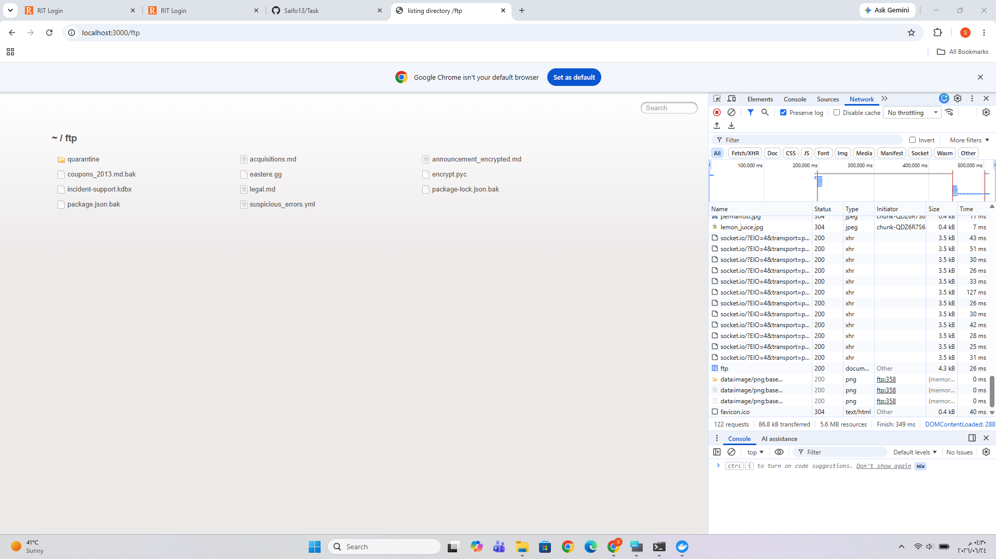

Unexpected /api path error evidence
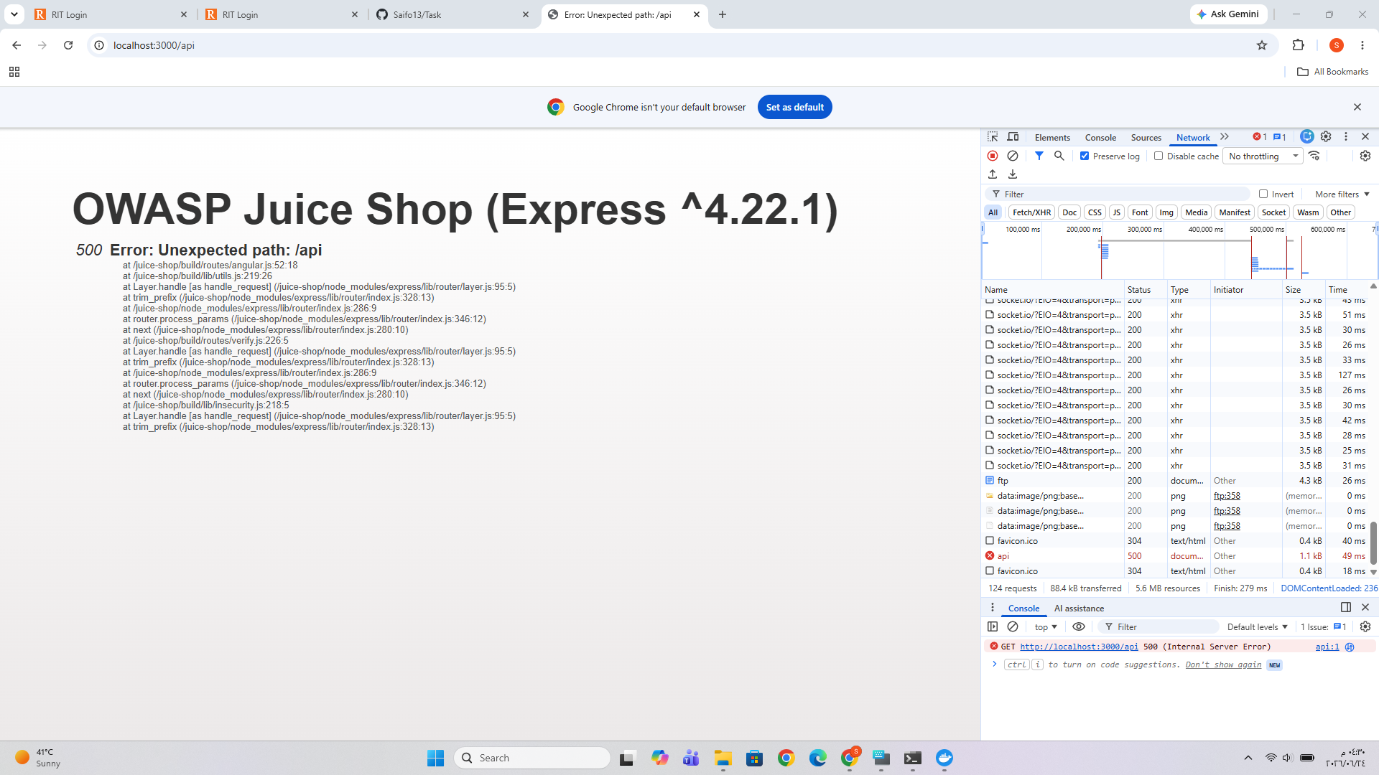

Repeated failed login evidence
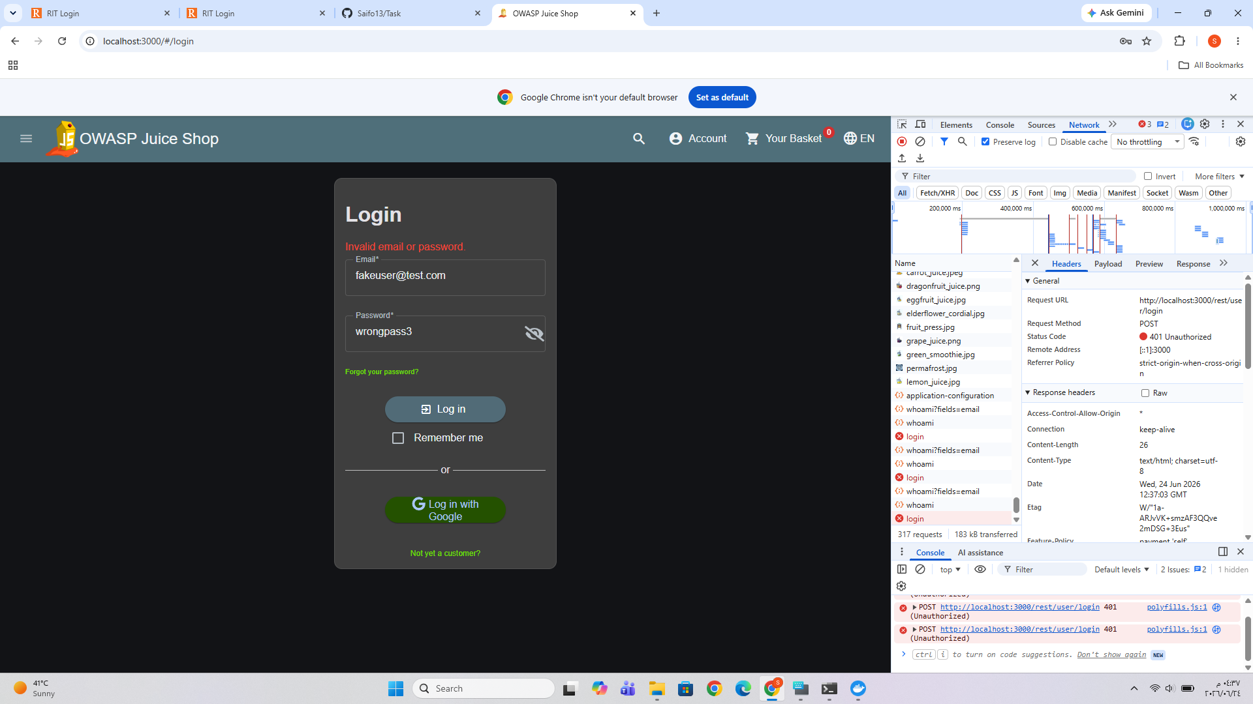

SQL injection login payload evidence
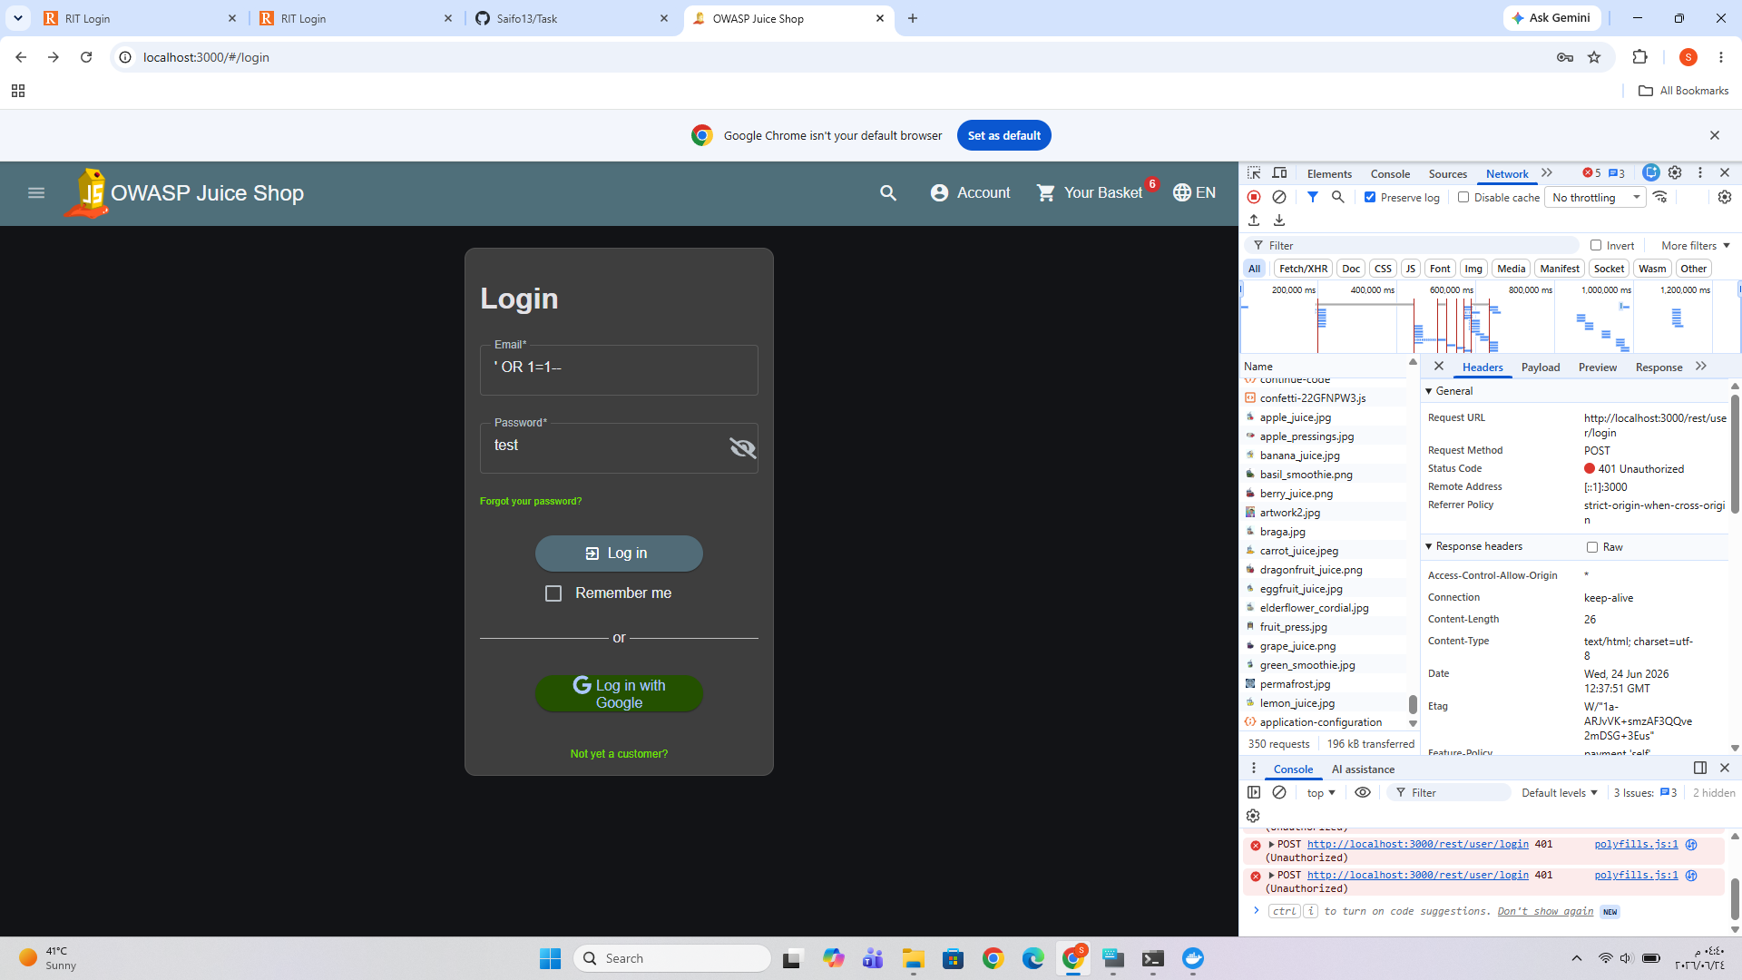

Admin session after SQL injection evidence
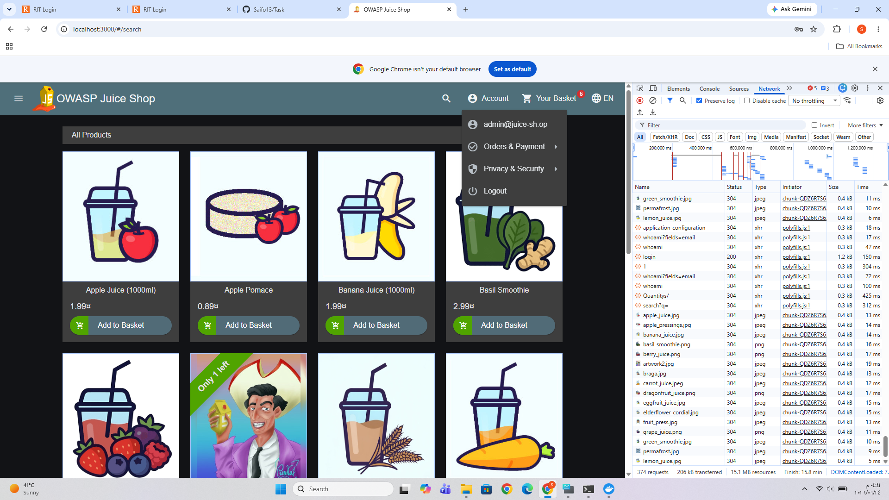

XSS alert evidence
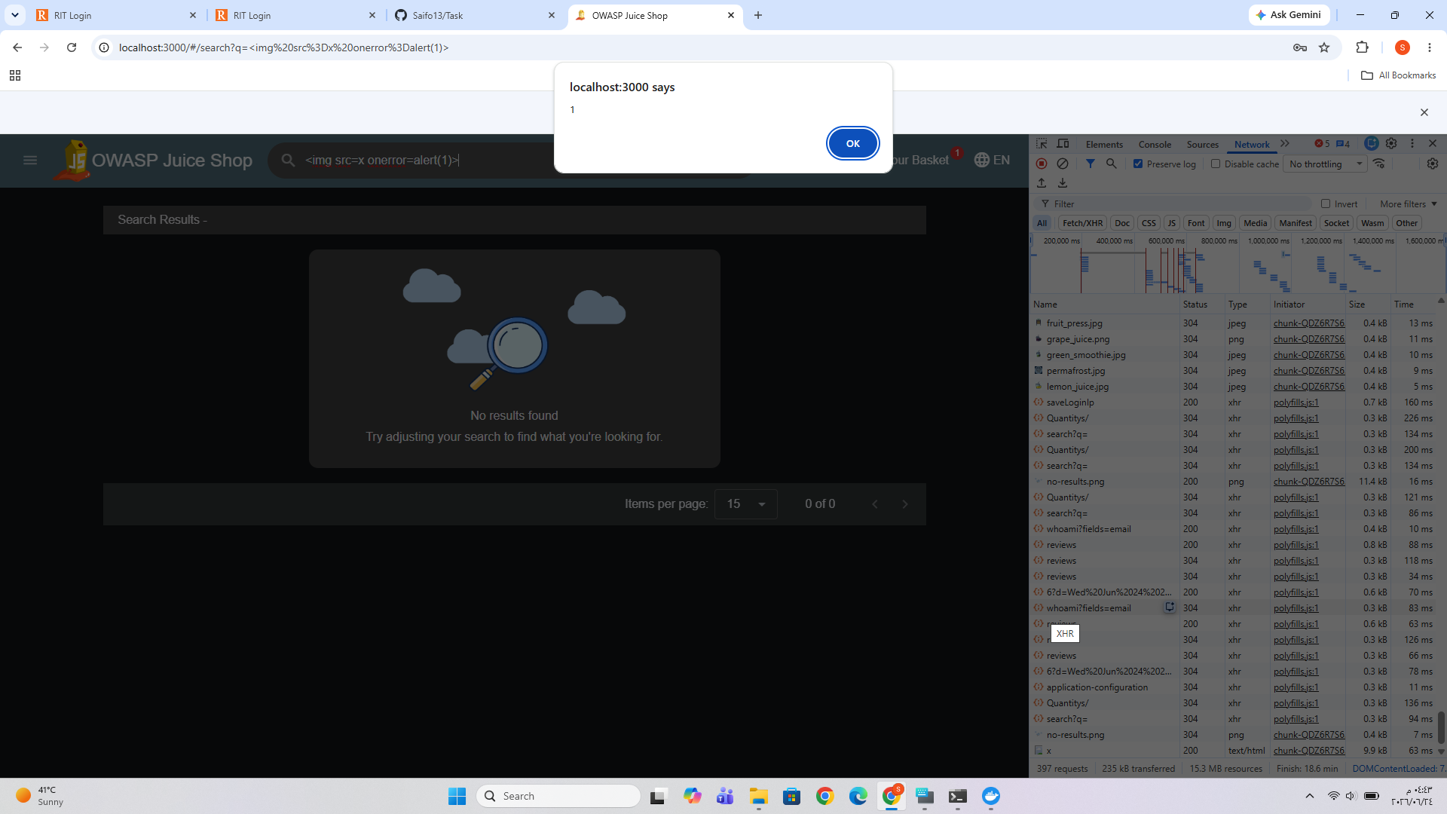

Whoami admin JSON evidence
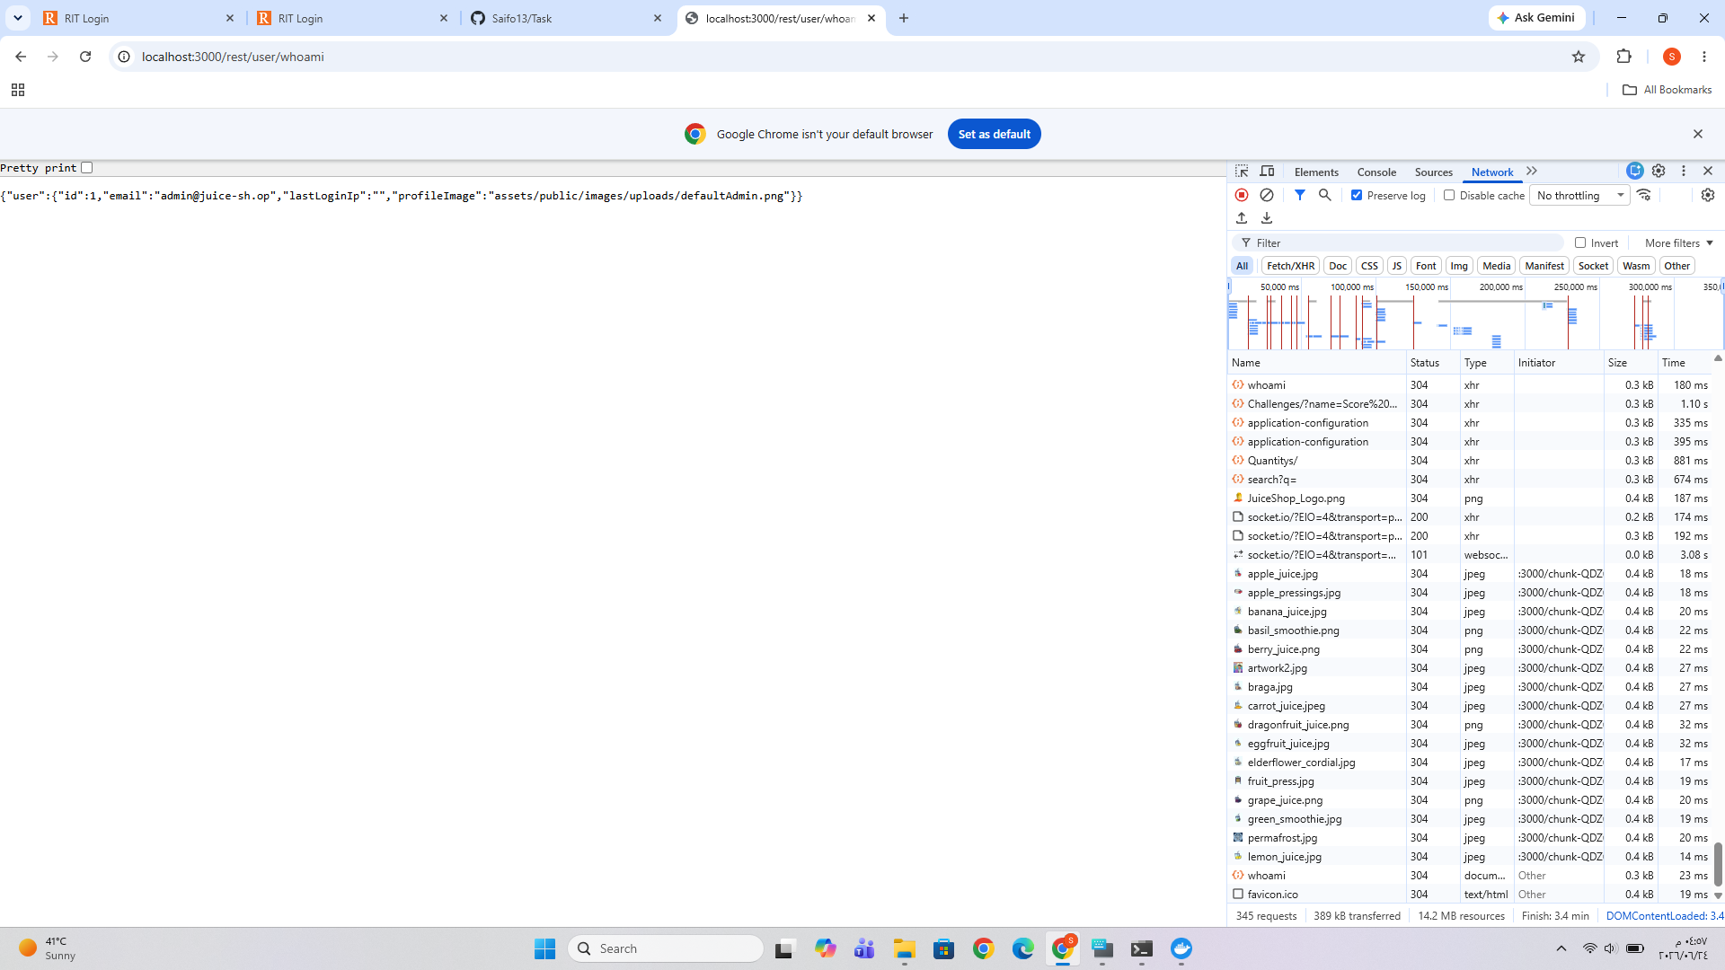

14. References
- MITRE ATT&CK, Technique T1190: Exploit Public-Facing Application, https://attack.mitre.org/techniques/T1190/
- MITRE ATT&CK, Technique T1595: Active Scanning, https://attack.mitre.org/techniques/T1595/
- MITRE ATT&CK, Technique T1110: Brute Force, https://attack.mitre.org/techniques/T1110/
- NIST, SP 800-61 Rev. 3: Incident Response Recommendations and Considerations for Cybersecurity Risk Management, https://csrc.nist.gov/pubs/sp/800/61/r3/final
- OWASP Foundation, OWASP Juice Shop, https://owasp.org/www-project-juice-shop/
- Operation Sentinel Lab Evidence, Docker logs, HAR export, and screenshots, 24 June 2026.

